**Balochistan:**

Bolan Pass

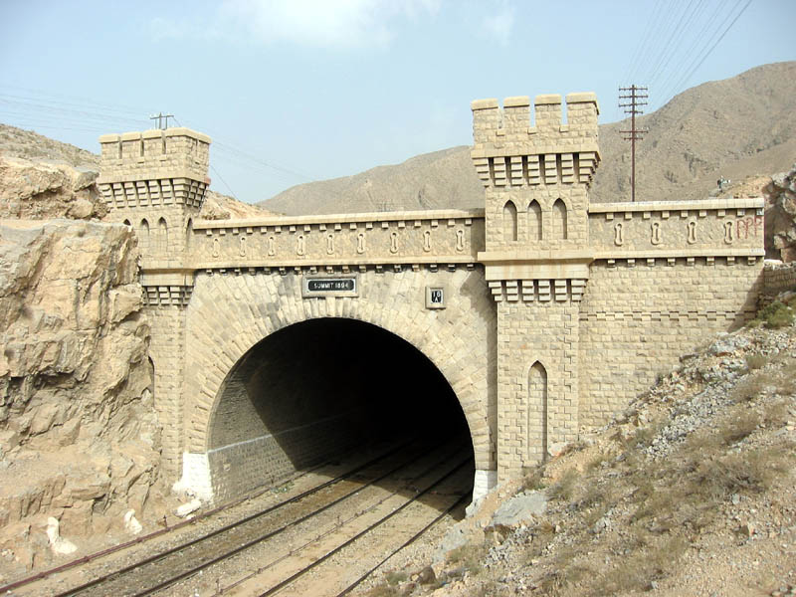

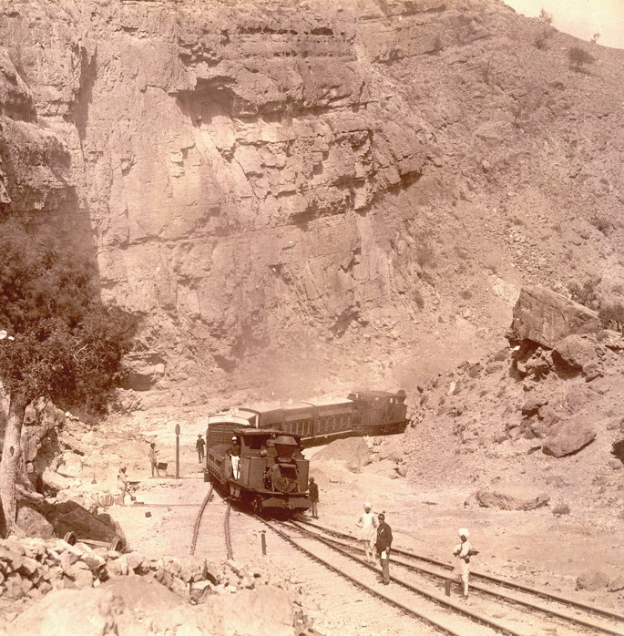

The **Bolān Pass** is a mountain pass through the Toba Kakar Range of Balochistan province in western Pakistan , 120km (75mi) from the Afghanistan border. The pass is an 89km (55mi) stretch of the Bolan river valley from Rindli in the south to Darwāza near Kolpur in the north. It is made up of a number of narrow gorges and stretches. It connects Sibi with Quetta both by road and railway.